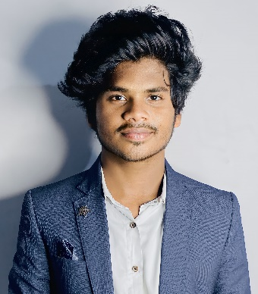**JANISH KUMAR U**

**MOBILE No:** 7339375997

**ADDRESS**: M.G.R NAGAR,2ND STREET,NANDIAMBAKKAM Chennai-120

**GITHUB LINK:** https://github.com/Janish25

**LINKEDIN:** https://linkedin.com/in/janish-kumar-2b170a259

**EMAIL-ID**:[janishkumarjk25@gmail.com](mailto:janishkumarjk25@gmail.com)**OBJECTIVE:**

Seeking a challenging position where I can leverage my expertise to drive organizational success and continue advancing in my career.

|  |  |  |  |  |
| --- | --- | --- | --- | --- |
| QUALIFICATION | INSTITUTION | UNIVERSITY/  BOARD | YEAR OF PASSING | PERCENTAGE |
| B.Tech(Information Technology) | Velammal Institute Of Technology, Panchetti | Anna University | 2021-2025 | **8.72 CGPA** |
| HSC | St.Anne’s Mat Hr Sec School | State Board | 2021 | **76.6%** |
| SSLC | St.Anne’s Mat Hr Sec School | State Board | 2019 | **83.8%** |

**ACADEMICCREDENTIALS:**

**TECHNICAL SKILLS:**

* Programming Languages : Java
* Web Technologies : HTML,CSS,Javascript,React js,Node.js
* Database : Mongo DB
* Figma,Photoshop
* Github

**AREAS OF INTEREST:**

* Object Oriented Programming
* Computer Network
* Cloud (AWS)

**PROJECTS :**

**NoBooks***(HTML,CSS,JS)* : Developed a Responsive learning website for students ,currently has OOPS concepts with embedded Compiler

**ZappyPhotography(Node,Express,MongoDB)** : Developed a full fledged Dynamic Website for Photography Which acts as a portfolio, Quotation Generator,Admin portal for Customization

**SmartAttendanceSystem** *(Python Libraries )* : Developed and built an Automated Attendance System Using OpenCv module

**Conference Website (Html,Css,JavaScript)** : Developed an Official Website for ICA5NT-2024.

**UI Design** *(Figma)* : Designed a comprehensive website for IETE portal compatible for all devices and Designed Instagram Clone,Movie Streaming application.

**MINI-PROJECTS :**

**Responsive-Portfolio,Calculator,Analog Clock,Weather finder,Qr code Generator,Text to Speech converter** *(HTML,CSS,JS)* : Designed and Developed these mini projects in my early stage of learning process

**FeedBack System with Login Authentication,** (Node,Express,Mongodb,Bootstrap):Implemented a Feedback portal which stores and retrieve Input values.

**Internship :**

* A month experince in Angular for frontend development and .NET Core with PostgreSQL for backend systems, expanding my technical proficiency at KY Technology,Crecsent Incubation center,vandalur.

**CERTIFICATION:**

* Certified in **Complete Web Development** by Udemy

**ACHIEVEMENTS:**

* **Dr.A.P.J.ABDUL KALAM YOUNG SCIENTIST ACHIEVER AWARD :** Received

the young scientist achiever award 2023 from Dr.A.Kalaanidhi(former vice chancellor , Anna University)

* **IEEE PUBLICATION-** Published a Conference Paper on the Topic of “Optimal Retrieval of data in cloud using Bellstra Algorithm.
* **IIC-IDEATHON:** Presented an idea on “Enhancing Computer Accessibility for Disabled People” and got Ist prize.
* **AWS VALUE ADDED COURSE :** Attended 5 days workshop and received certificate
* **FIGMA** : Won 3rd prize in UI/UX designing competition (inter college level)

**CO-CURICULAR ACTIVITIES:**

* Member at **IIC**
* Member at **NSS**

**PERSONAL DETAILS:**

**DATE OF BIRTH :** 25.12.2003

**LANGUAGES KNOWN :** Tamil, English

**HOBBIES :** Playing Guitar,Dancing,Listening to songs, Sketching

**DECLARATION:**

I hereby declare that the above-mentioned information is correct and appropriate to my knowledge

**PLACE: Chennai DATE: (JANISH KUMAR.U)**